**

**Wave Propagation and Antennas**

**Assignment # 02**

**Submitted To:**

Dr Zeeshan Zahid

**Submitted By:**

Muhammad Ali

**Submitted On:**

18th June, 2022.

**Course:**

BEE 56D

**Patch Antenna at 10GHz**

Q: Simulate Patch Antenna at 10GHz in HFSS and show its results in the report.

**Solution:**

To design Patch Antenna at 10GHz frequency first of all we will find its dimensions.

**Calculations**

Frequency = fr = 10GHz

𝜀𝑟 (duroid) = 2.2

h = 1.588cm

* **Patch Width:**



**Width = 1.186cm**

* **Patch Length:**

For length we need **𝜀𝑟eff** and **ΔL**,



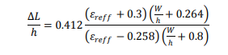



**Length = 0.906cm**

* **Ground and Substrate Dimensions:**



**Lg = 1.8588cm**

**Wg = 2.1388cm**

**HFSS Simulation**

**Step 1:**

First of all, ground is drawn with the calculated dimensions.

L = 18.588mm and W = 21.388mm

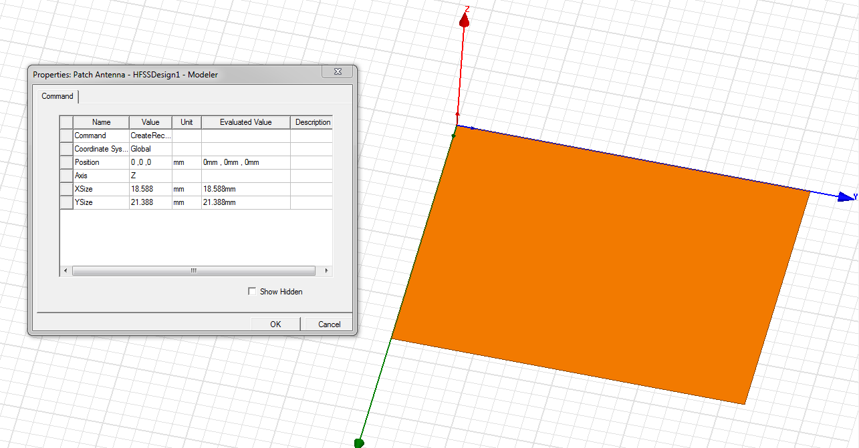

**Step 2:**

Ground’s boundary is assigned as perfect electrical conductor.

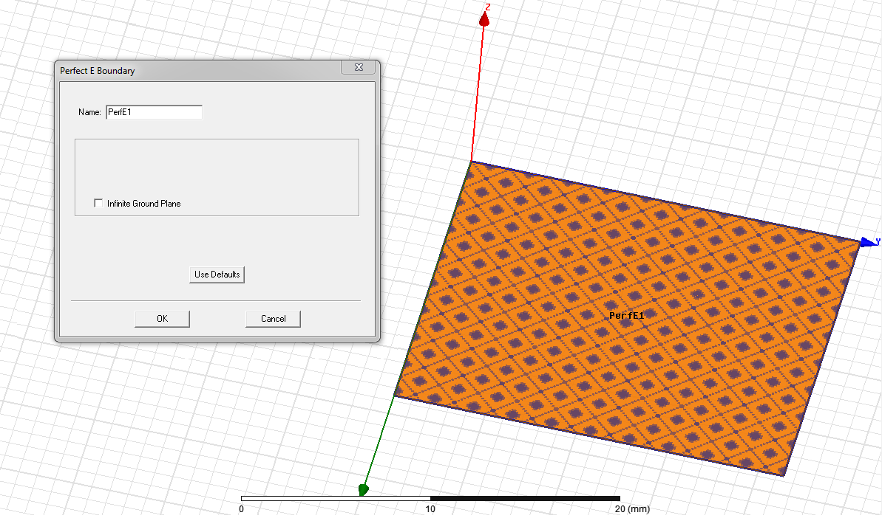

**Step 3:**

Substrate is drawn with same dimensions as of ground.

H = 1.588mm, L = 18.588mm and W = 21.388mm

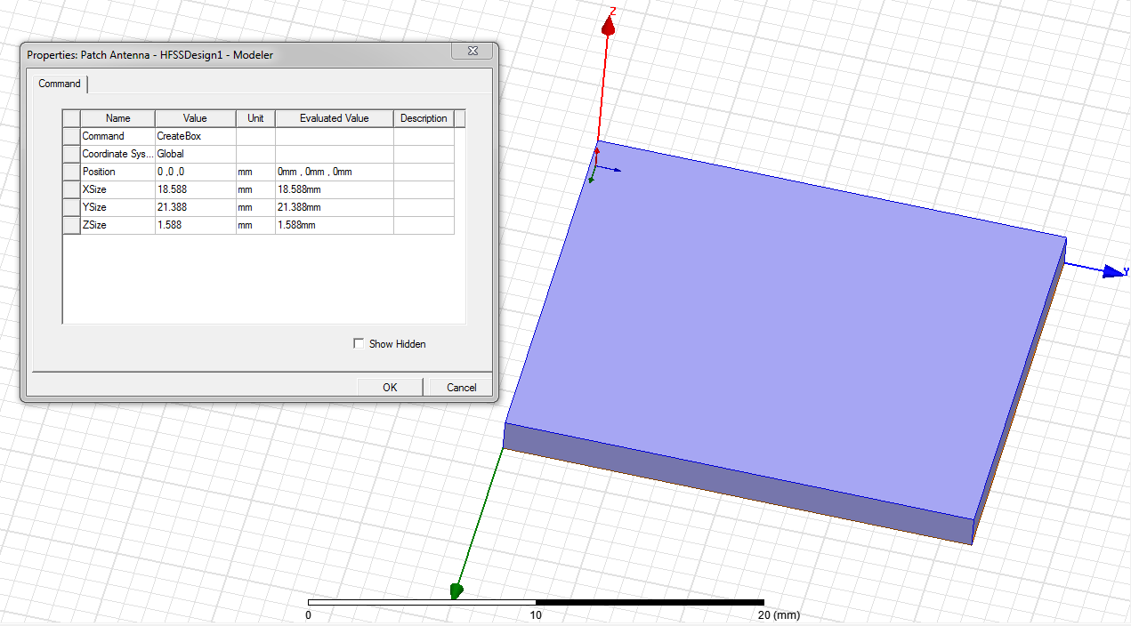

**Step 3:**

Substrate is assigned as **Duroid** Material.

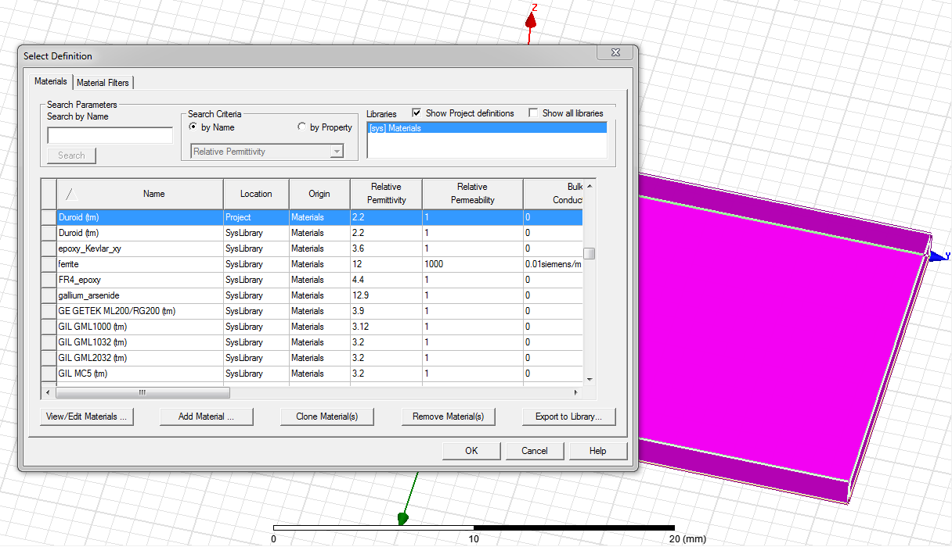

**Step 4:**

Patch with calculated width and length is drawn.

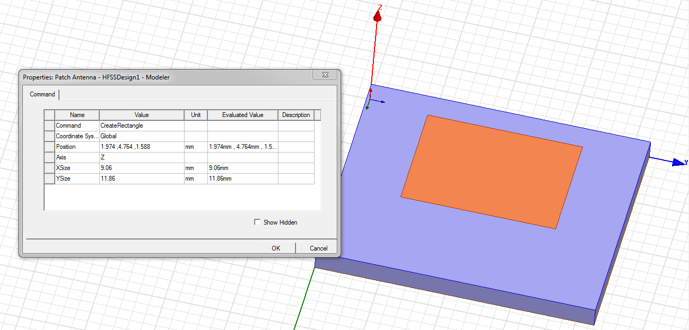

**Step 5:**

Patch is subtracted with a rectangle with yo calculated.

**yo = L = 0.3126cm** and **W = 2h = 0.3176cm**

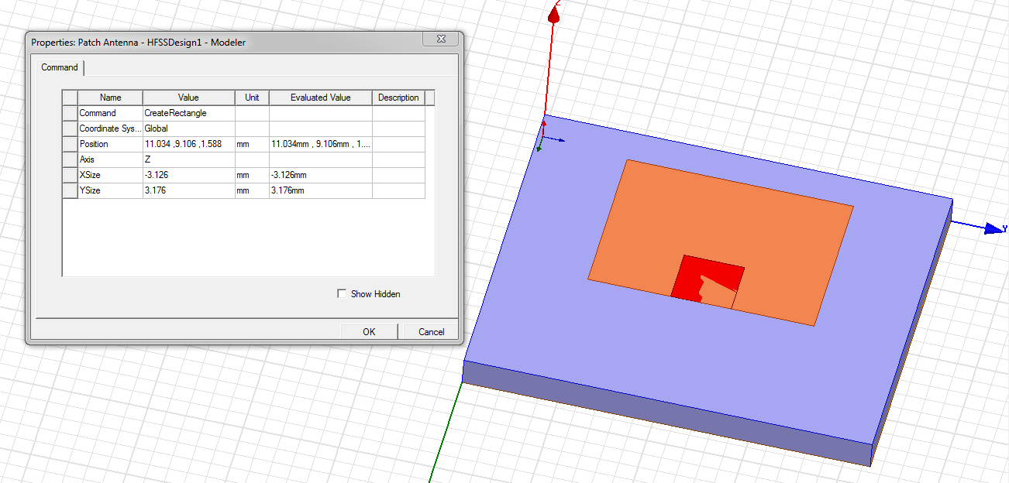

After subtraction:

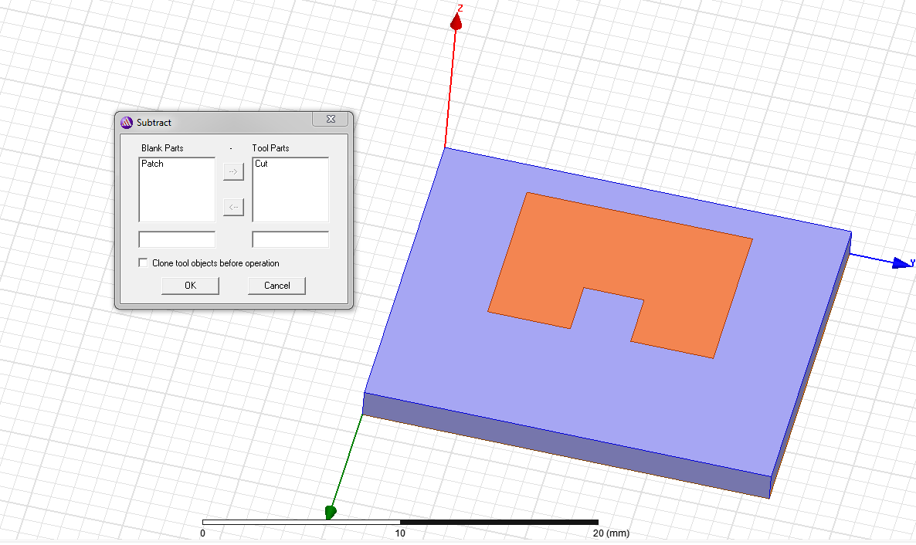

**Step 6:**

Patch is connected with feed line.

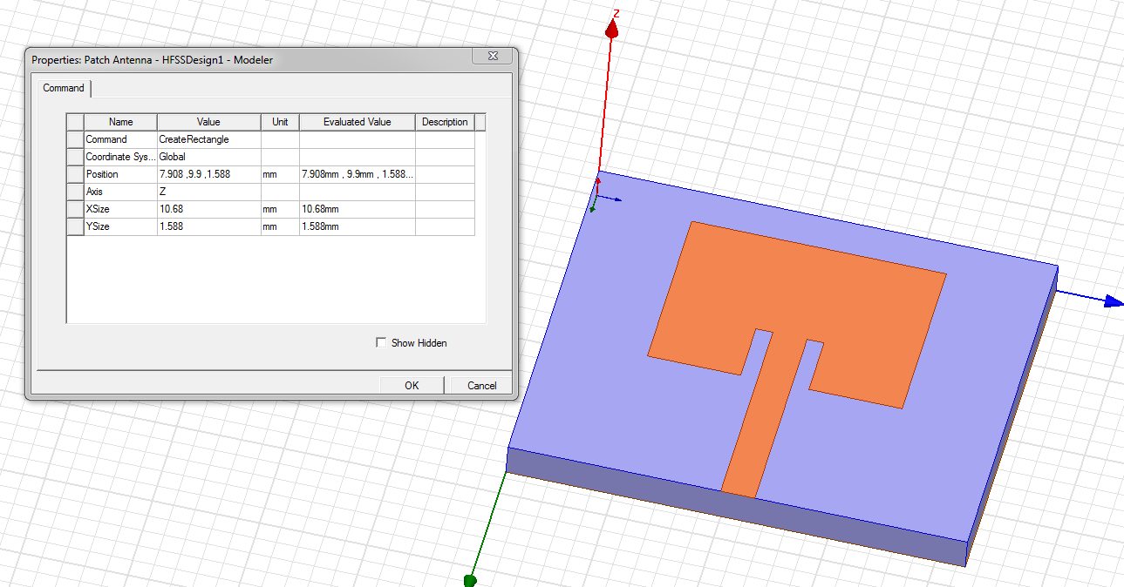

**Step 8:**

Patch’s boundary is assigned as perfect electrical conductor.

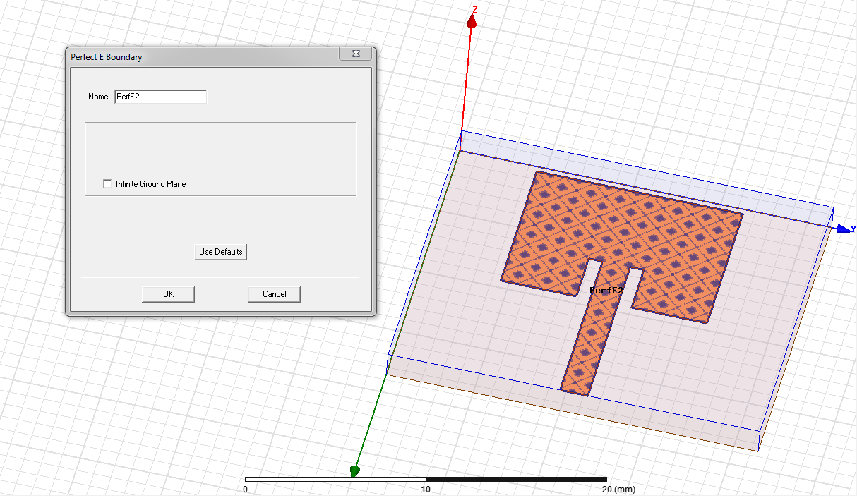

**Step 9:**

Excitation point is created in YZ-plane connected with the feed.

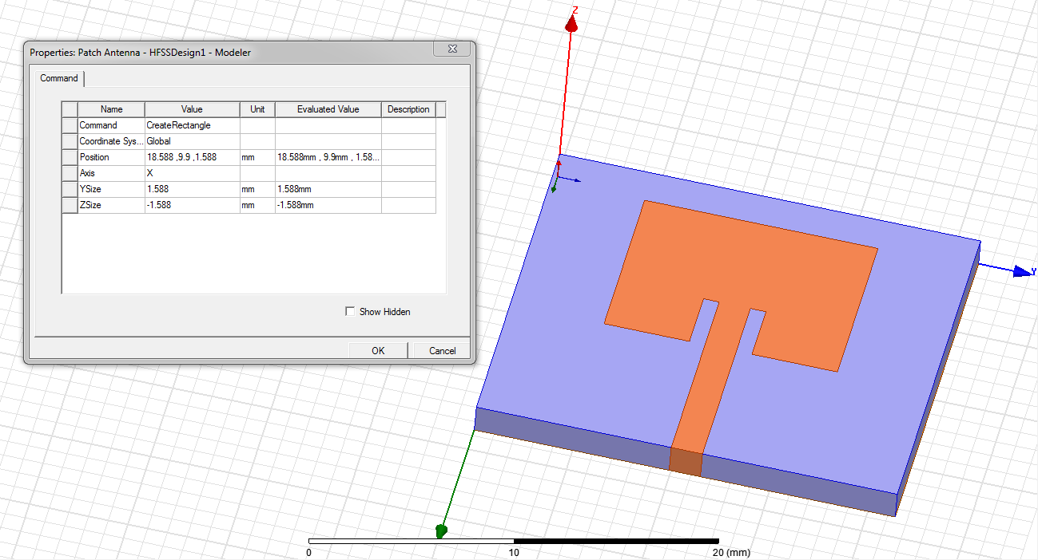

**Step 10:**

Excitation is assigned.

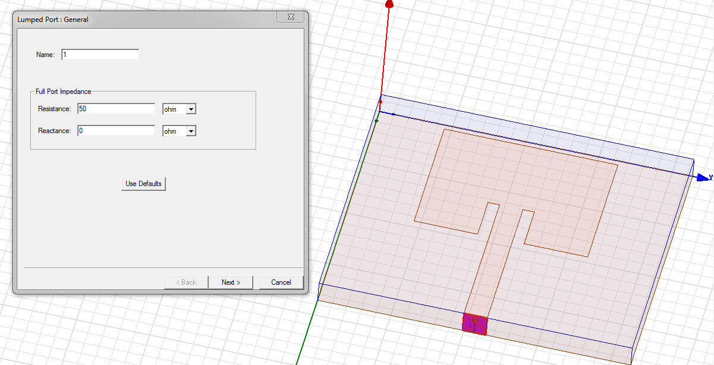

**Step 11:**

Box is created to capture Radiations.

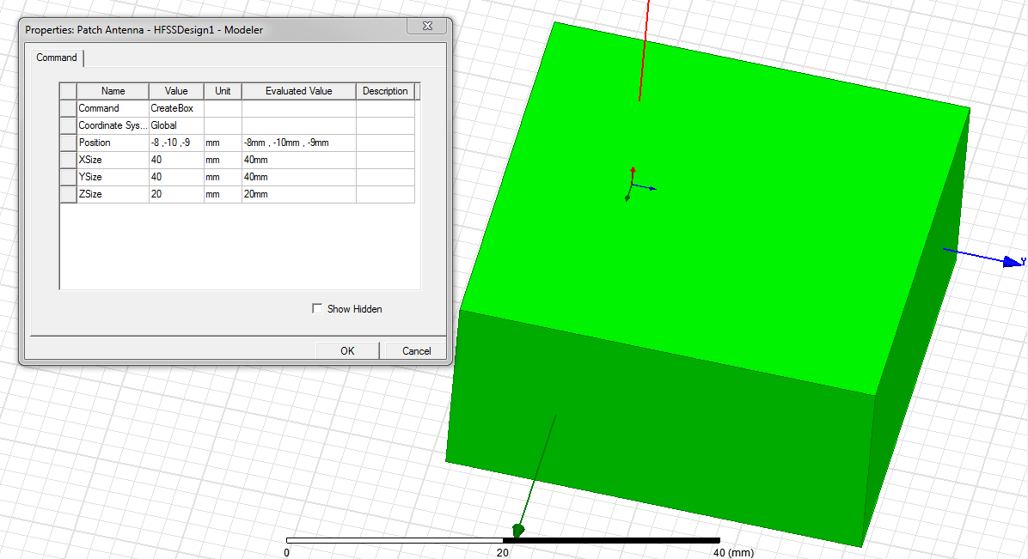

**Step 12:**

Radiation boundary is assigned.

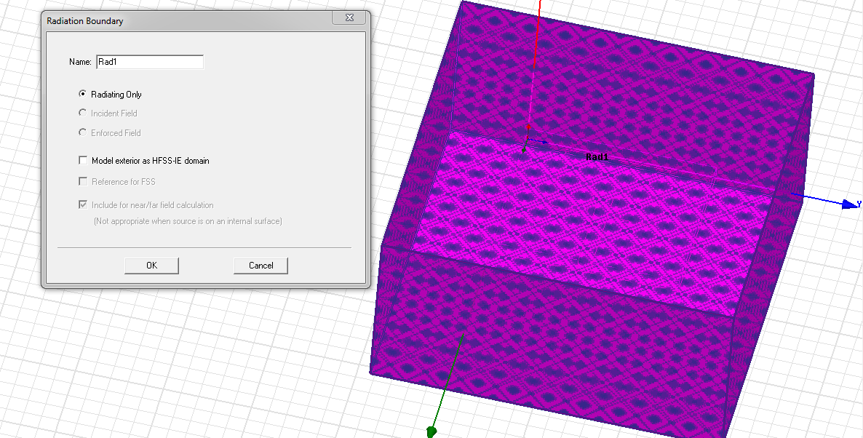

**Step 13:**

Frequency sweep and far field setup is done.

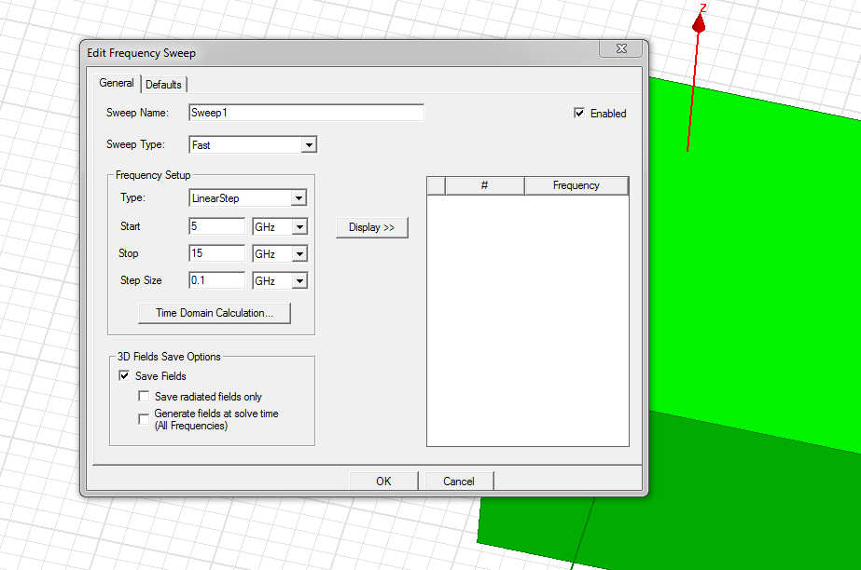

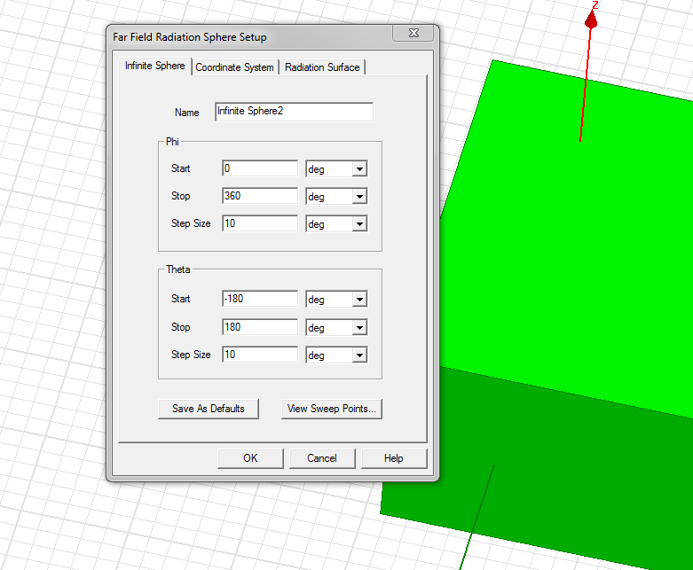

Design is simulated to see results.

**Results**

Resonant at 10GHz. **S (1,1) Plot:**

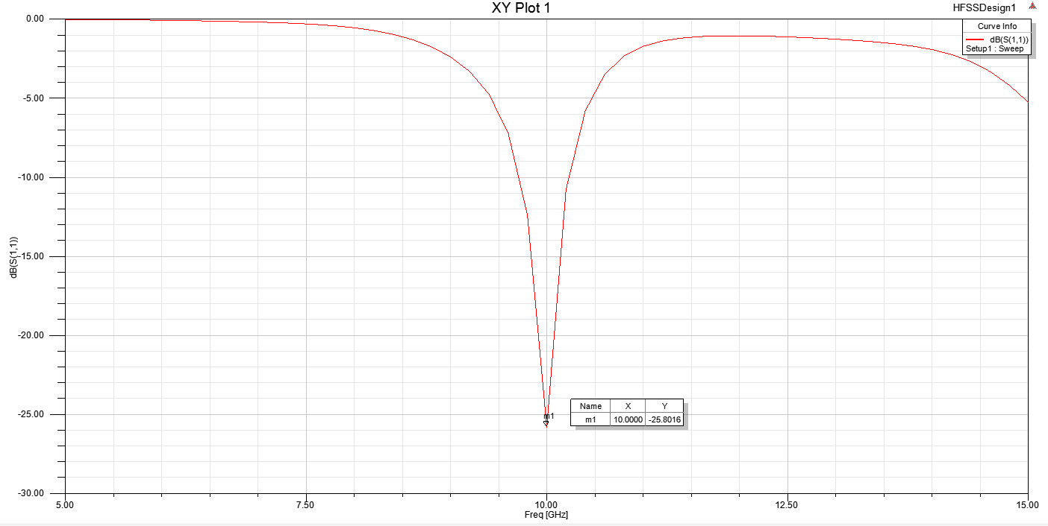

Imaginary part is almost zero at 10GHz. Which means the antenna is resonant.

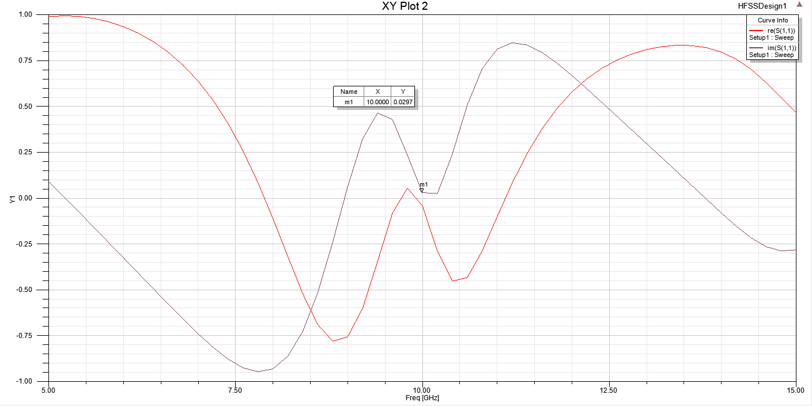

**Smith Chart Plot:**

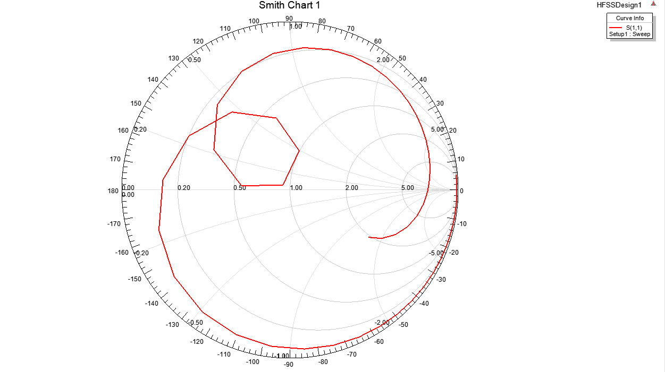

**Radiation Pattern:**

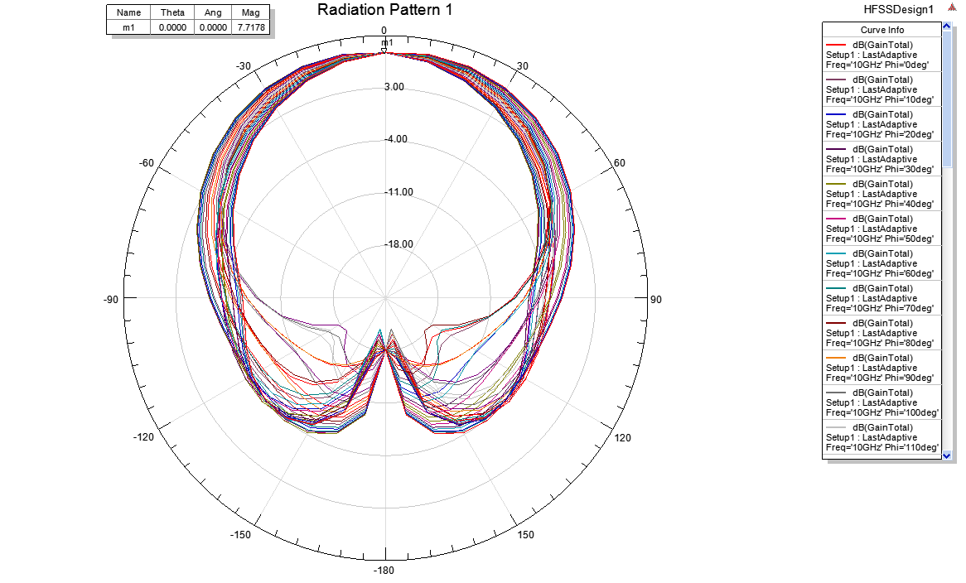

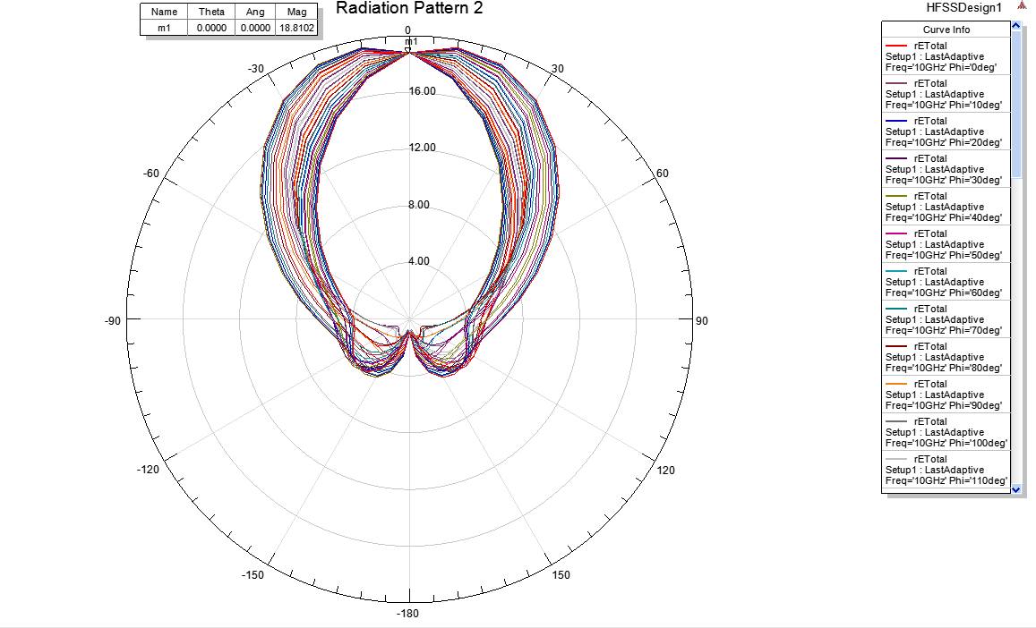

**3D Polar Plot:**

